Tai Nguyen

Yong Jiang

Matthew Lisec

**~Spring 2018a~**

**CST363 Introduction to Database Systems**

**Class project**



**Part 1: Project description (100 points)**

Note: at least three tables are required in this project

In this project, you are to apply what we have learned to design and implement a database system for an organization/company of your choice, it could be a library, restaurant, car repair shop, pet clinic etc. In the first part of the project, you are required to:

1. provide a summary of the scope of your project: brief description of the organization, information needs and questions that need to be addressed, and the purpose of your database system.

For our project we going to build a database to help people apply for a mortgage. We will have 4 tables: User table, Application Table, Borrower table, and Debts table

The user table will be the person that is navigating the website. This may or may not be the borrower. The user could also be an agent that the borrower has hired, so the user could potentially have many borrowers that he is trying to apply for a loan for.

The borrower is where most of the required information comes from. This is what type of loan that the borrower qualifies comes from. The user may add borrowers’ information without necessarily applying for a loan. This table will also tie directly to debts if the borrower has any. The debts table will show all kinds of debts that the user still has an outstanding balance in if any.

The Loan Application table will show which applications are still open. Multiple borrowers can apply for a single loan, and multiple loans can come from a single borrower.

1. draw ER diagram 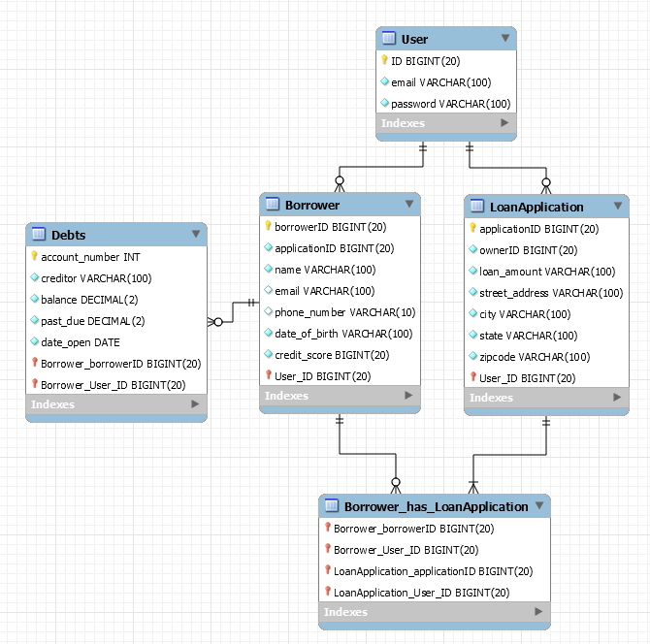
2. check the ER diagram for normal form. Modify the design to normalize it, or explain why it is better to keep an unnormalized design.